Abdallah Salhab

21110181

\*The ultrasonic parking sensor:

-how does it work: when you decrease the distance between the sensor and the object a buzzer starts to make a beeping sound and the number of beeps increase when you get closer and closer until a certain point it then keeps beeping constantly.

-the needed components for the project:

1-an ultrasonic sensor 2-a buzzer 3-arduino uno 4-bread board 5- cables

Description of the most used parts in these projects:

\* Arduino uno: The Arduino Uno is a microcontroller, which provides a set of digital and analog input/output pins that can be programmed to perform various tasks.

\* Bread board : A breadboard is a fundamental tool used in electronics for building and testing circuits without the need for soldering. It provides a platform for quickly and easily connecting electronic components and creating temporary circuits.

Description of the components used in this project:

\*Ultrasonic sensor: An ultrasonic sensor is a device that uses sound waves to measure the distance to or detect the presence of objects. It operates based on the principle of echolocation gust like how bats navigate in the dark.

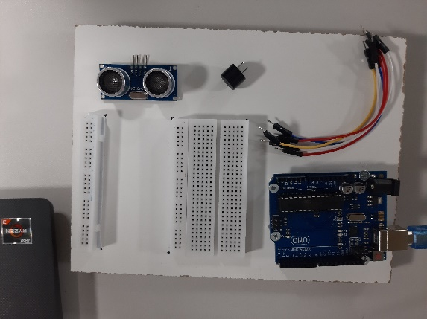\*Buzzer: A buzzer is a simple electronic component that produces sound when activated. It is commonly used to provide audible feedback or alerts.

to put together the device :

first, the ultrasonic sensor has four pins one goes to the ground and the VCC goes to the 5v, the echo is connected the 9 digital pin and the trig is connected to the 10 digital pin.

Secondly, one end of the buzzer is connected to the ground and the other one is connected to the 11 digital pin.

\*\*evaluation: the ultrasonic and buzzer preformed as expected and if buzzes faster and faster whenever it comes closer to an object and they can be used as a parking helper device on cars.

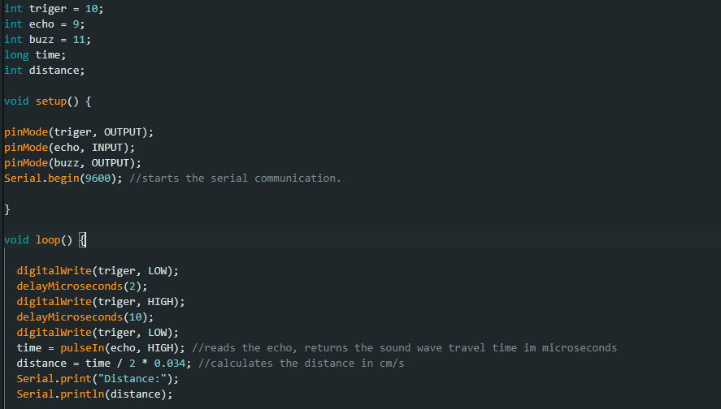  


\*\*\*\*\*\*\*\*\*\*\*\*\*\*\*\*\*\*\*\*\*\*\*\*\*\*\*\*\*\*\*\*\*\*\*\*\*\*\*\*\*\*\*\*\*\*\*\*\*\*\*\*\*\*\*\*\*\*\*\*\*\*\*\*

\*The servo motor project:  
-how it works: there is a potentiometer that can be manually used to change the direction of the servo motor.

-the needed components for the project:

1- a servo motor 2-a potentiometer 3-arduino uno 4- bread board 5- cables

Description of the components used in this project:

\*Servo motor: A servo motor is a type of electric motor its main characteristic is its ability to rotate an output shaft to a specific angle.

\*Potentiometer: A potentiometer, often referred to as a pot, is a variable resistor that allows for manual adjustment of electrical resistance. It consists of a resistive element and a sliding contact, also known as a wiper, which moves along the resistive track.

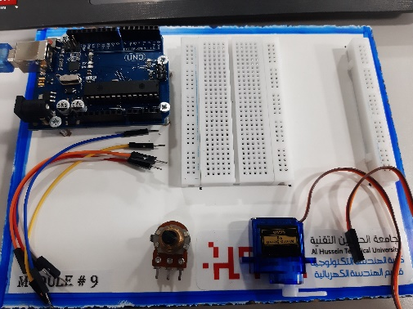to put together the device :

first the servo motor has three cables one is connected to the ground and the VCC is connected to the 5v pin and the signal is connected to the 9 digital pin.

Secondly, the potentiometer has three pins one is connected to the ground and the other one is connected to the A0 analog pin and the last one is connected to the 5v.

\*\*evaluation: when you move the potentiometer the servo motor moves accordingly, and it can be used to control the angle of security cameras



\*\*\*\*\*\*\*\*\*\*\*\*\*\*\*\*\*\*\*\*\*\*\*\*\*\*\*\*\*\*\*\*\*\*\*\*\*\*\*\*\*\*\*\*\*\*\*\*\*\*\*\*\*\*\*\*\*\*\*\*\*\*\*\*\*\*\*

\*The black and white detecting ir sensor:

-how it works: there is an ir sensor and a light that is used to detect bright and dark objects, so the light is off when the ir sensor is Infront a bright object and the light will turn on if the ir sensor is Infront of a dark object, and it also portable using a 9v battery.

-the needed components for the project:

1-ir sensor 2-led and a resistor 3-9v battery 4-arduino uno 5-cables 6-bread board

Description of the components used in this project:

\*IR sensor: An IR (Infrared) sensor is a device that detects infrared radiation in its surrounding environment. It is commonly used for proximity sensing, object detection, and in remote controls.

\*Resistor: a resistor primary function is to resist the flow of current and limit the amount of current passing through a circuit.

\*Led: is a semiconductor device that emits light when an electric current passes through it.

\*Battery: is a device that stores and provides electrical energy in the form of direct current.

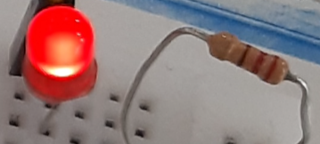

to put together the device :

First, connect the led and the resistor in series between the ground and the 4 digital pin.

Secondly, the ir sensor has three pins one is connected to the ground and the other is connected to the 5v and the last one is connected to the 13 digital pin.

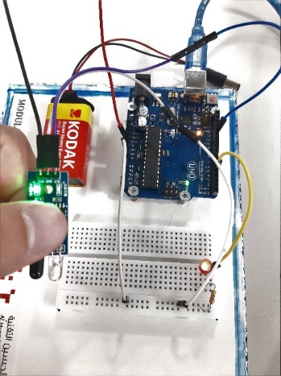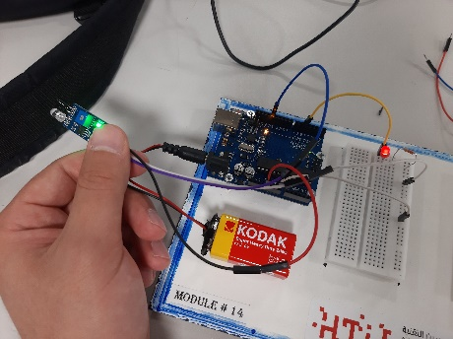

\*\*evaluation: this device defranciate between white and black objects (or reflictive objects) and it can be used as a a divice that can defranciate between painted and unpainted products (assuming that the unpainted parts are black and that painted ones are white) in a manufacturing company.

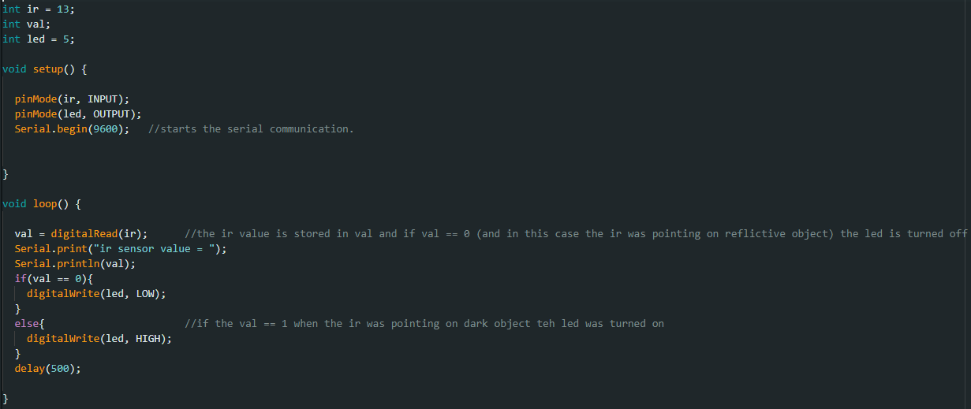

\*\*\*\*\*\*\*\*\*\*\*\*\*\*\*\*\*\*\*\*\*\*\*\*\*\*\*\*\*\*\*\*\*\*\*\*\*\*\*\*\*\*\*\*\*\*\*\*\*\*\*\*\*\*\*\*\*\*\*\*\*\*\*\*\*\*\*

\*The wheel project:  
-how it works: there is a wheel that is driven by a dc motor, the dc motor is connected to a h.bridge, the speed of the motor can be controlled manually using a potentiometer and the direction of the wheel can be changed using a button.

-the needed components for the project:

1-dc motor 2-potentiometer 3-button 4-h.bridge 5-arduino uno 6-cables

7-bread board

Description of the components used in this project:

\*DC motor: is an electrical device that converts electrical energy into mechanical rotational motion.

\*H.bridge: it is an electronic circuit configuration commonly used to control the direction and speed of a DC motor. It allows the motor to rotate in both forward and reverse directions.

\*Button: is a simple mechanical device used to control the flow of electricity in an electrical or electronic circuit

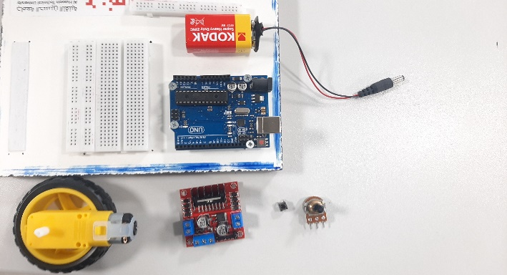

to put together the device :

first you have to connect the dc motor to the side of the H.bridge and then from the blue connector that has three connections, connect the first and the last connectors to the 5v and connect the middle one to the ground, and connect the ENA connector to the D9 digital pin and the IN1 to the D7 digital pin and the IN2 to the D6 digital pin.

Secondly connect one of the sides of the button with the D12 digital pin and the other with ground.

Lastly connect the first leg of the potentiometer into the 5v and the second one with the A0 analog pin and the last one with ground.

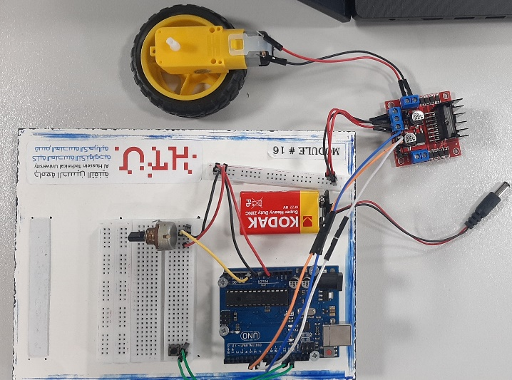

\*\*evaluation: the motor speed can be changed using the potentiometer and the button changes the direction of the motor, using four motors like this and every two are connected to a cylinder and between them is a belt, this can be used as the as the mall cashier counter that moves to get the products in reach of the cashier and the speed and direction can be controlled.

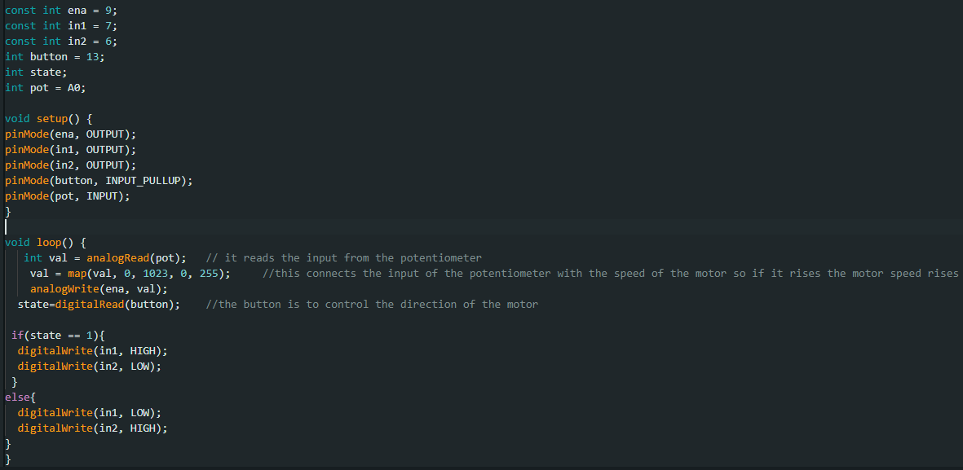

\*\*\*\*\*\*\*\*\*\*\*\*\*\*\*\*\*\*\*\*\*\*\*\*\*\*\*\*\*\*\*\*\*\*\*\*\*\*\*\*\*\*\*\*\*\*\*\*\*\*\*\*\*\*\*\*\*\*\*\*\*\*\*\*\*\*\*

\*The keypad that controls the positions of a servo motor.

-how it works: there is a keypad that controls the angle of the servo motor so if you press 1 the position of the servo becomes 0, if you press 2 the position of the servo becomes 45, if you press 3 the position of the servo becomes 90, if you press 4 the position of the servo becomes 135, if you press 5 the position of the servo becomes 180.

-the needed components for the project:

1-Keypad 2-servomotor 3-arduino uno 4-cables 5-bread board

Description of the components used in this project:

\*Keypad: A keypad is an input device consisting of a set of buttons arranged in a grid.

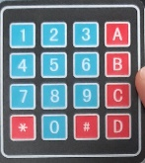

to put together the device :

First the keypad has place for 8 connectors, and these must be connected respectively from the D2 digital pin to D9 digital pin.

Secondly the servo motor has three pins the first one goes to the ground the second one to the 5v and the third one goes to the D10 digital pin.

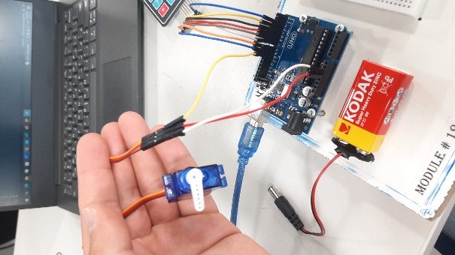\*\*evaluation: this device changes the servo motor direction according to pre-configured degree using the keypad, it can be used to in modern vehicles to change the angles of the mirrors if the car is used by deferent users (if they were pre-configured)so it is easier than to change them manually.





\*\*\*\*\*\*\*\*\*\*\*\*\*\*\*\*\*\*\*\*\*\*\*\*\*\*\*\*\*\*\*\*\*\*\*\*\*\*\*\*\*\*\*\*\*\*\*\*\*\*\*\*\*\*\*\*\*\*\*\*\*\*\*\*\*\*\*

\*LCD that displays the temperature:

-how it works: There is a temperature sensor that monitors the temperature, and the display displays the rating.

-the needed components for the project:  
1- LCD 2-tempreture sensor 3-arduino uno 4-cables 5-bread board

Description of the components used in this project:

\*LCD: is a flat panel display technology that uses liquid crystals to create visual output. It is widely used in electronic devices such as televisions, computer monitors, smartphones, and digital clocks.

\*Temperature sensor: is a device used to measure and monitor temperature. It detects changes in temperature and converts them into an electrical signal that can be easily interpreted and processed by other electronic components.

to put together the device :

the LCD has four connectors the first goes to the ground the VCC goes to the 5V and the SDA goes to the A4 analog pin and t eh SCL goes to the A5 analog pin.

The temperature sensor has three connectors the first goes to the 5v and the second oner goes to the A0 analog pin and the third one goes to the ground.

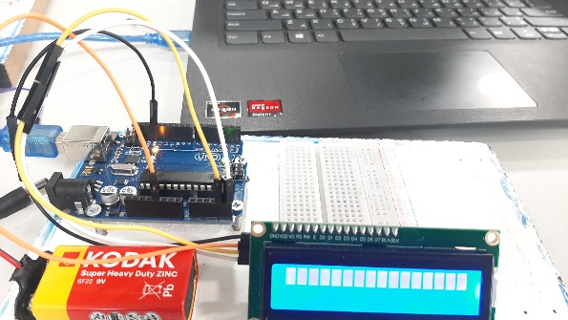\*\*evaluation: this device displays the temperature on a LCD, it can be used to monitor the temperatures of the car to insure that it does not over heat.

